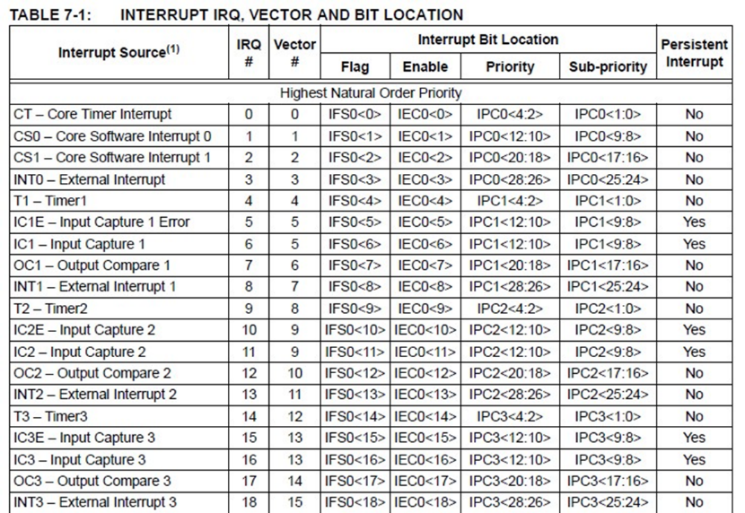**Hardware exceptions:** user or processor, external interrupts or internal timers.

**Software exceptions:** Illegal instructions, divide by 0, traps i.e. *(int*) (0x0000000)

**Exception Handling: Resets –** power on reset, external resets, watchdog, and clock monitor reset.

**Watchdog:** counts down to 0x0 and then resets processor, can’t turn off after turning on (except reset).

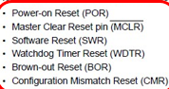**Clock Monitor:** resets when system clock frequency drops below prescribed value.

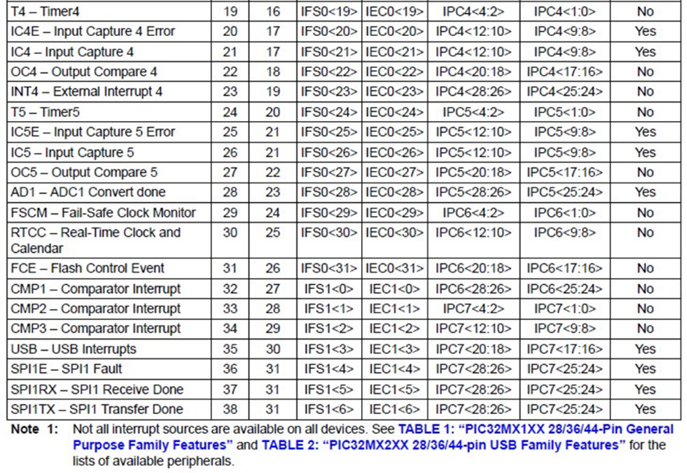**Brown-out:** supply voltage goes below threshold.

**Asynchronous Interrupt:** I/O - communication, Errors

**Synchronous Interrupts:** I/O – update periodically, Processes – switch between tasks, Timing- measure elapsed time.

**Maskable Interrupt:** enabled and disabled in software

**Non-Maskable:** enabled by software, only disabled by hardware.

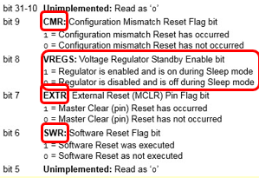

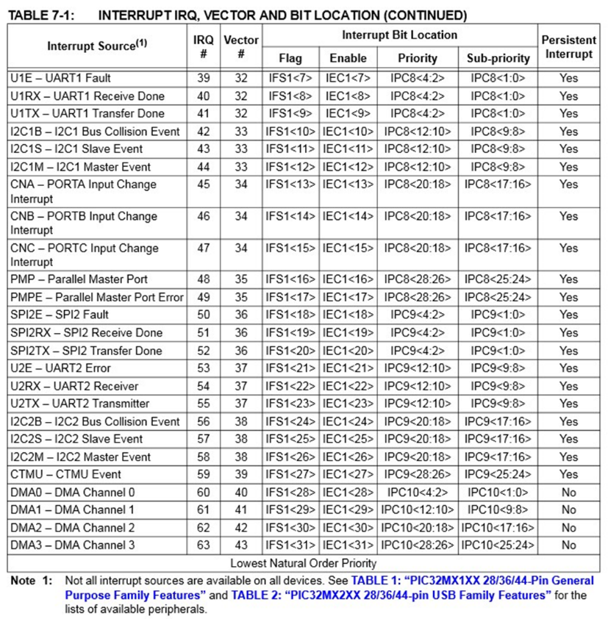

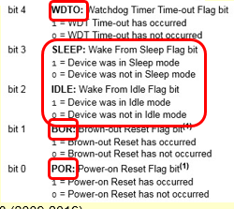

RCON:

**IP, IS:** bits 7:0 – IP00, IS00. bits 15:8 – IP01, IS01. bits 23:16 – IP02, IS02. Bits 31:24 – IP03, IS03.

**External interrupts:** INTCONbits.INTxEP – sets edge polarity (0 falling, 1 rising).

- **void __ISR(_EXTERNAL_0_VECTOR, ipl2) Int0_IRQ(void);**

- **void __attribute__( (interrupt(ipl2), vector(_EXTERNAL_0_VECTOR))) Int0_IRQ ( void );**

-

- **Input capture:** counts pulses until rising/falling edge to determine duty factors, measure Pulse width etc.

- **Output compare:** like alarm clock, create signal after predefined time has elapsed. Make PWM

- **OSCCON -**  oscillator function

- bit 21 – PBDIVRDY and 20/19 PBDIV

- PBDIV divides SYSCLK by 1, 2, 4, 8 (default) for 00, 01, 10, 11

-

- **Core timer –** uses COUNT and COMPARE registers can be used to generate interrupt when COMPARE = COUNT. Interrupt 0.

- COUNT has ½ frequency of SYSCLK.

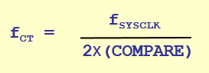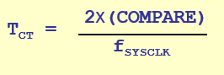

- CP0_GET_COUNT(), CPO_SET_COUNT(value), CP0_GET_COMPARE(), CP0_SET_COMPARE(val).

- **Timers:** PIC32 has TMR1-TMR5.

- **Type A Timer:** TMR1 sync/async 16-bit

**- Type B Timers**: TMR2- TMR5 syn 16-bit but can be

Combined, 2/3 & 4/5 to use as 32-bit

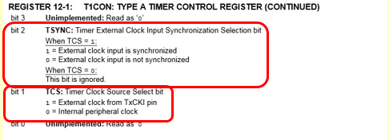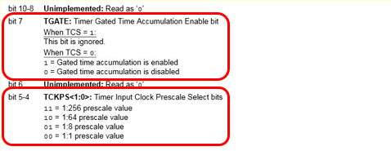Type A: T1CON

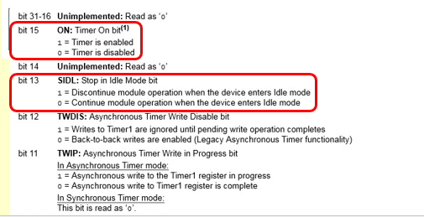**- Input Capture:** PIC32 has 5

### ADD 1 TO PRy

Type B: TxCON, x = [2,5]

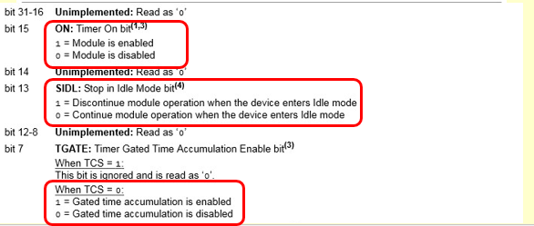

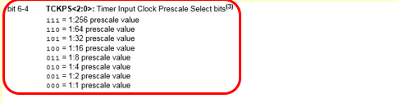

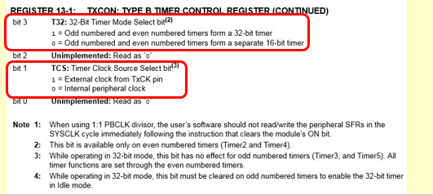

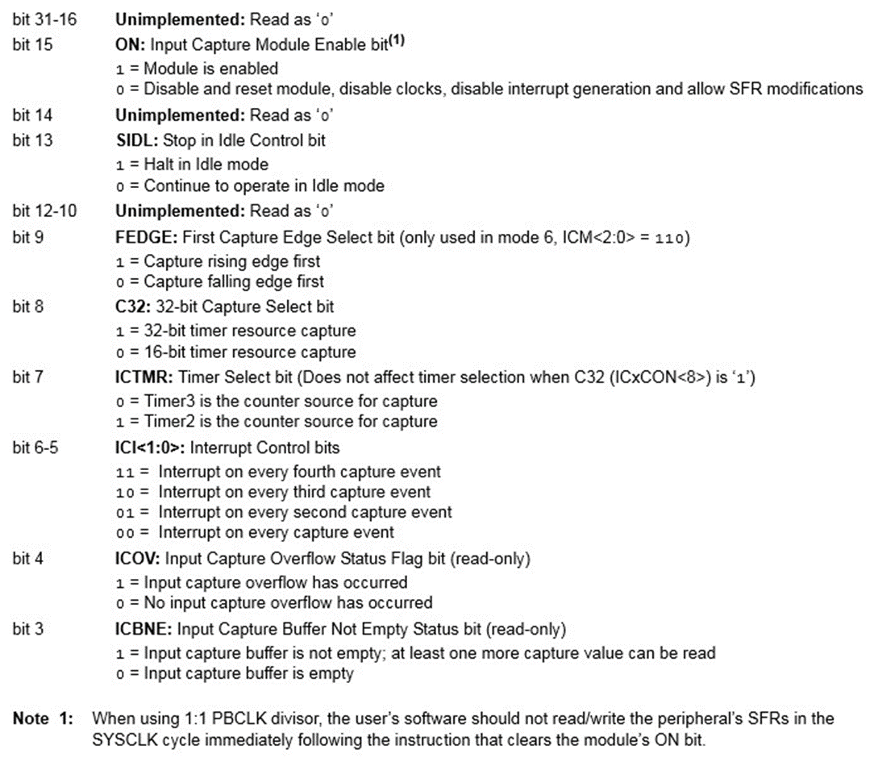 **Input Capture: ICxCON, x = [1,5]**

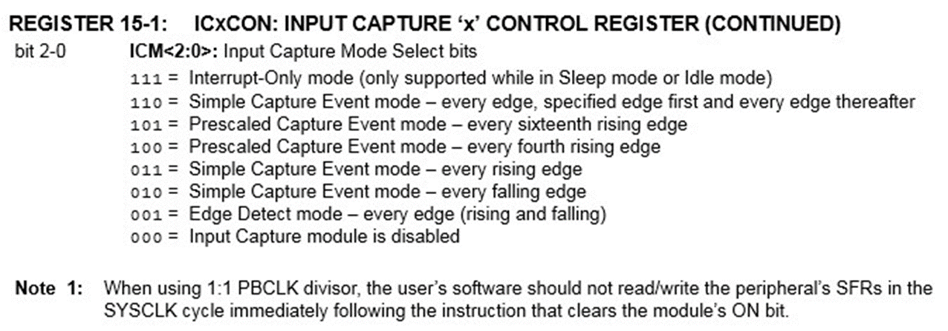

# Output compare – OCxCON, x = [1,5]

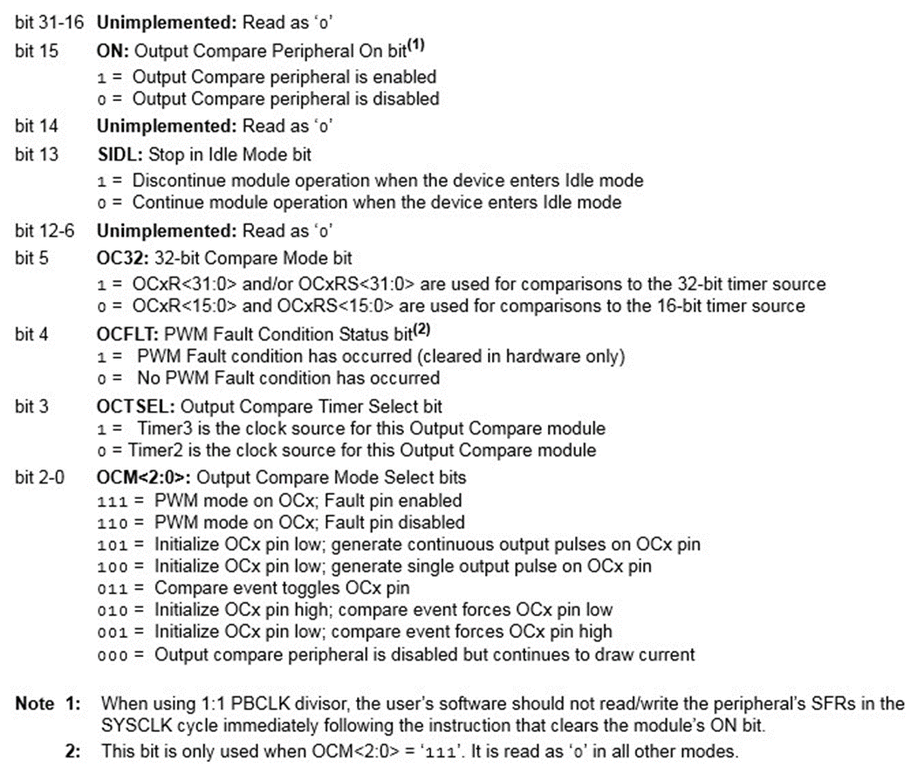- **Square Wave Calcs:** final frequency / 2 - half period on.

- **RPM:** Let N = number of “equally spaced events”

f_tmr = timer frequency

ticks = TMRx(new) – TMRx(old)

**RPM = 60 / (N * (ticks/f_tmr))**

**- Watchdog timer – STWD100**

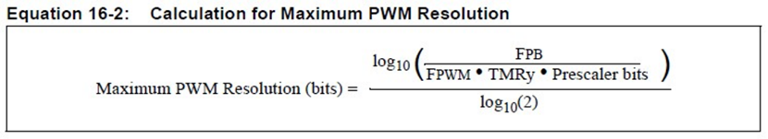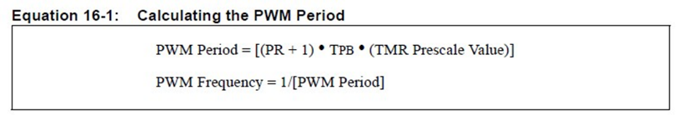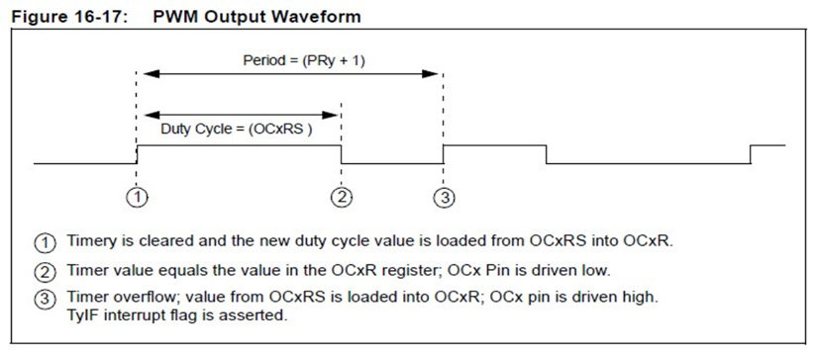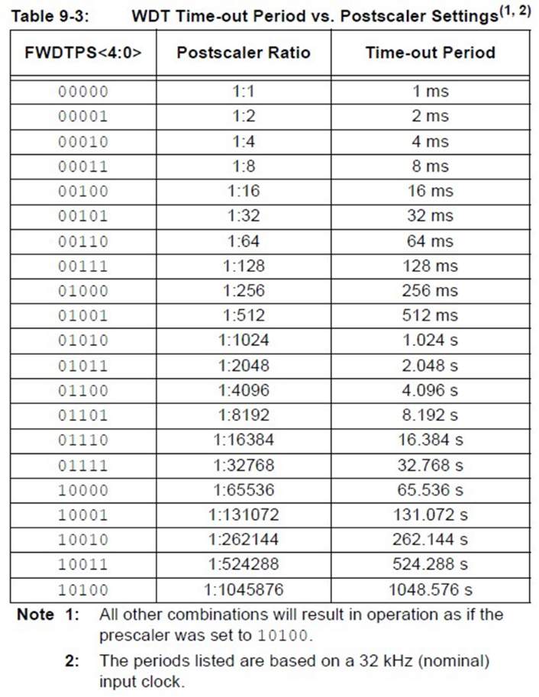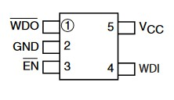

**DEVCGF1 – FWDTEN** 1 = on

## RCON --^ ------ PWM ------v

**Max RES^^**  DON’T ROUND/TRUNCATE

**Serial Peripheral Interface (SPI) -** Full Duplex

**Inter Integrated Circuits (I^2C) -** Half Duplex

**MOSI –** Master Out Slave In (Data out)

**MISO –** Master In Slave Out (Data in)

**SCK –** Serial clock

**SS#** - Slave Select

PIC32 has **2 SPI** peripherals available

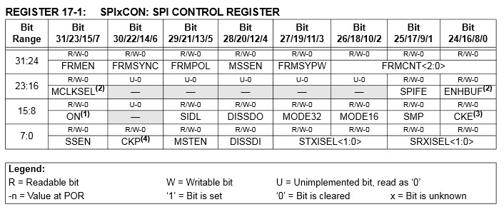

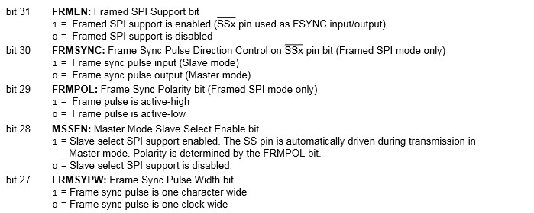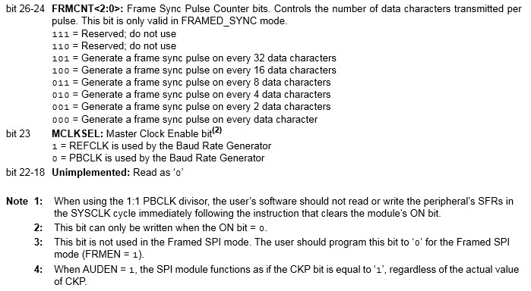

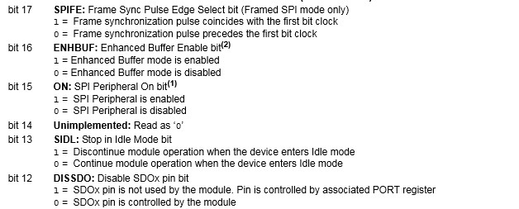

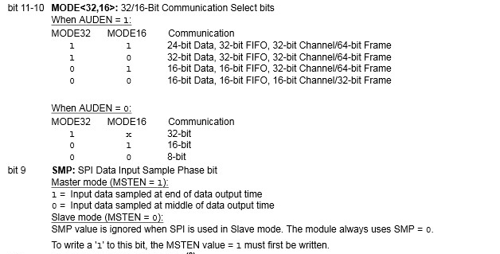

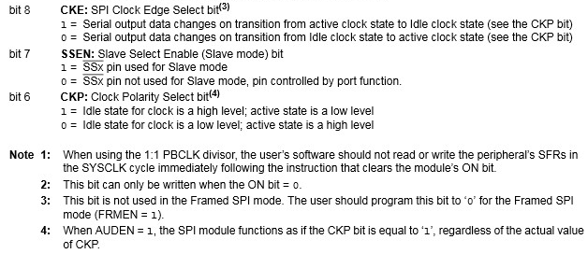

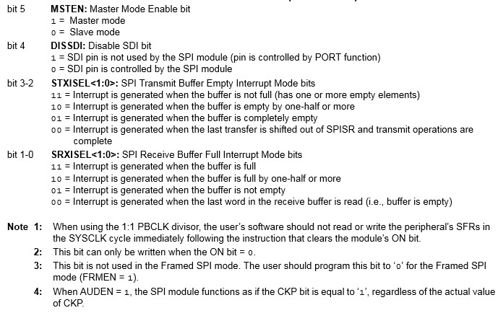

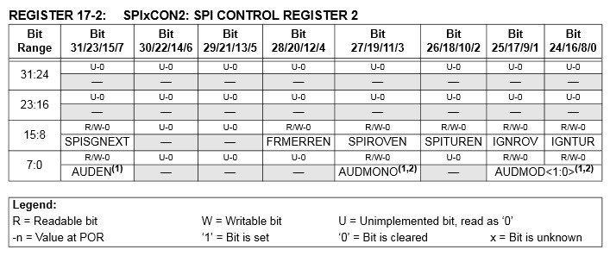

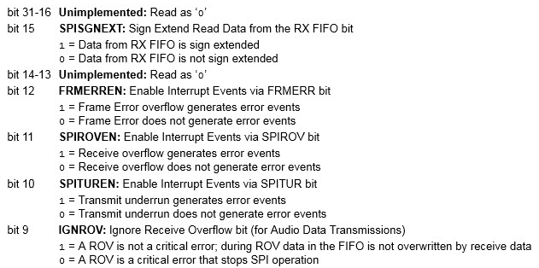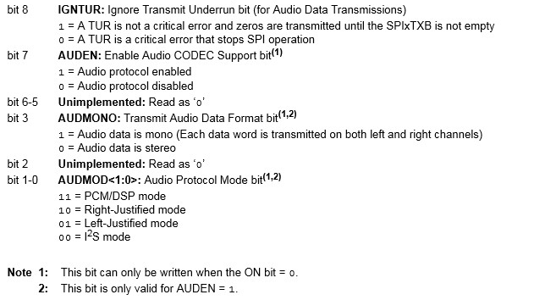

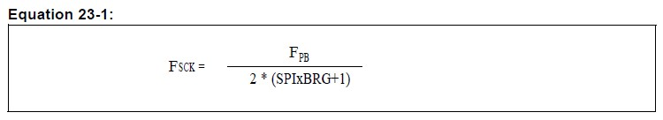

- **SPIxBRG<0:8>** - Baud rate register

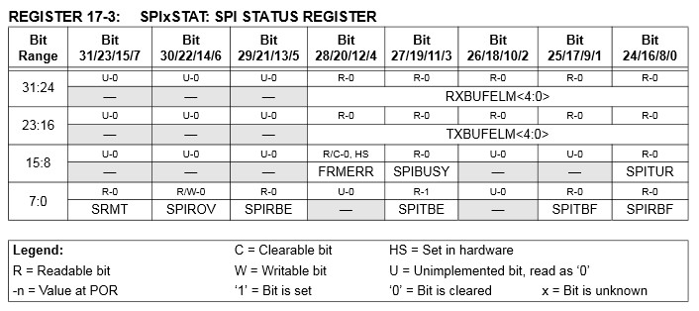

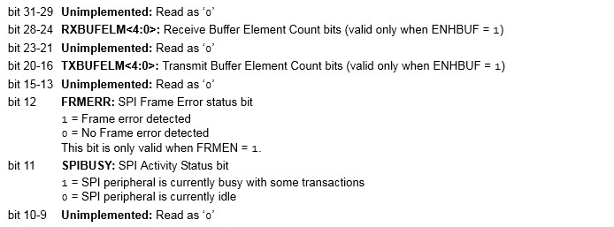

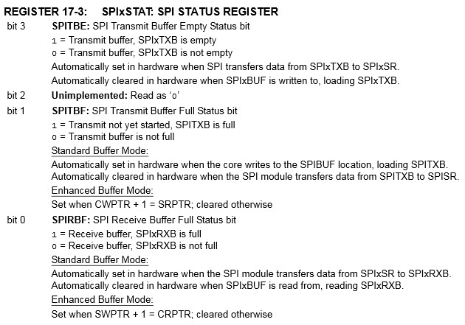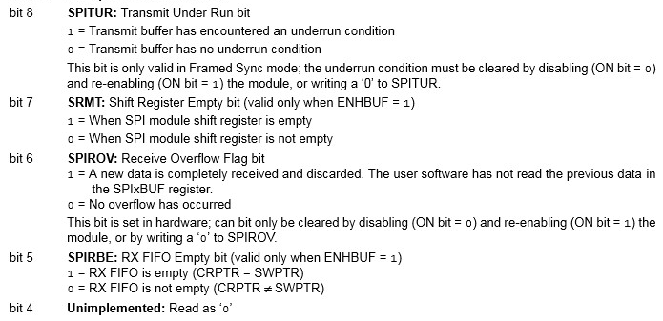

# PIC32 has 3 comparators

# CVRCON

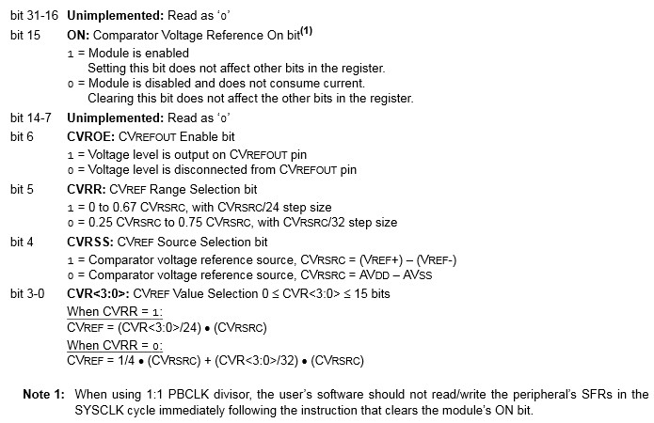

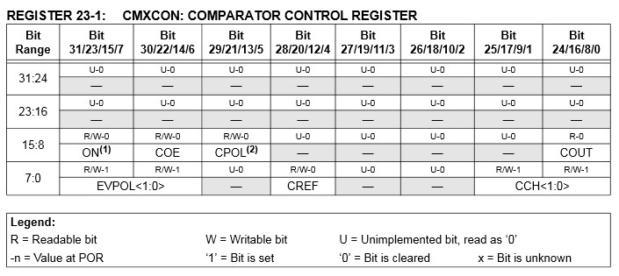

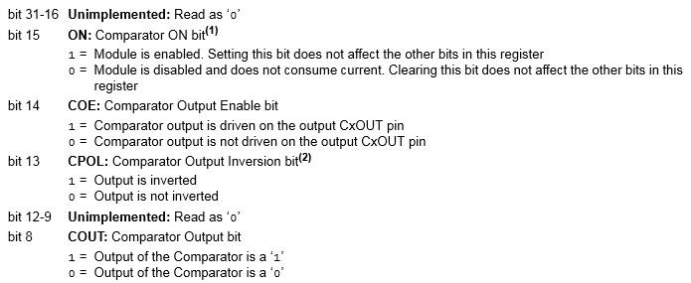

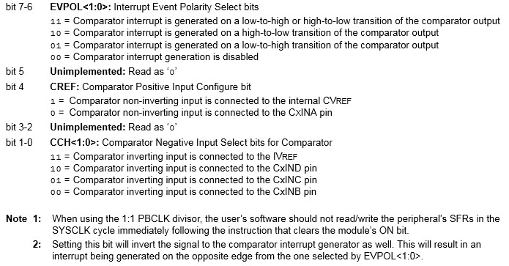

D to A:



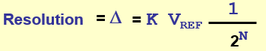

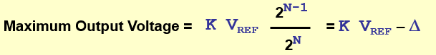

**Zero Error –** error when input = 0

**Full-Scale Error -** error when input is the maximum

**Relative Accuracy Error –** error between actual and the line from output_max and output_min.

**Monotonicity -** outputalways increasing as input increases

**Settling Time -** The required for the output to reach with a D/2 of the stable output when the input changes from 0 to 2N-1, or 2N-1 to 0.

A-to-D:

**Offset Error** - Error of analog transition point nearest 0 Volts.

**Full Scale (Gain) Error** - Error of analog transition point farthest from 0 Volts.

**Differential Nonlinearity Error** - The maximum difference between a step D and the constant ideal D.

**DNLE = Maximum |Dk – D|**

**A *Successive Approximation Register* (SAR)** is an ADC where each output bit is determined sequentially, starting with the most significant bit (MSB) working down to the least significant bit (LSB) in a binary search algorithm.

**Dual-Ramp ADCs use an RC Operational Amplifier Circuit coupled with a timer to measure the value of an input.**

* Slower but more precise because it needs to charge and discharge a capacitor.

**PIC32 A-to-D:**

* 10 bit, up to 16 analog inputs, internal VREF, multiple channel scan, 16-word buffer, 8 conversion formats and can run during idle/sleep mode.

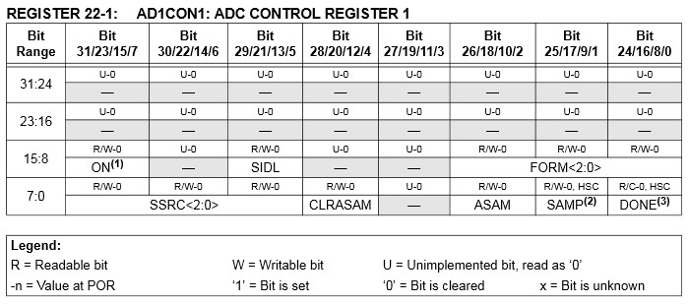

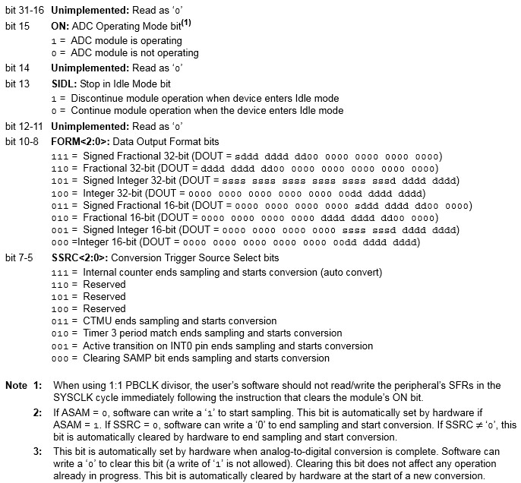

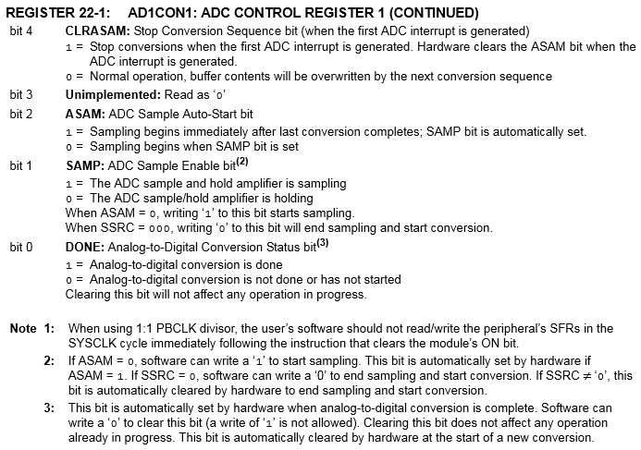

* Signed voltages: Vad = ( # / 1024 ) * VREF+
  + (VREF+ **-** VREF-) / 2 + Vad
  + For fractions add 1 if POSITIVE

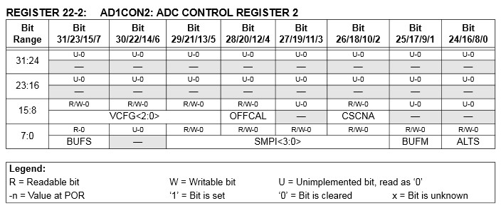

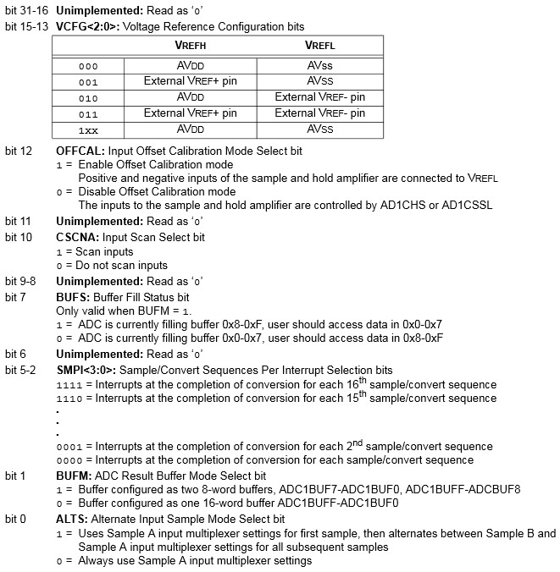

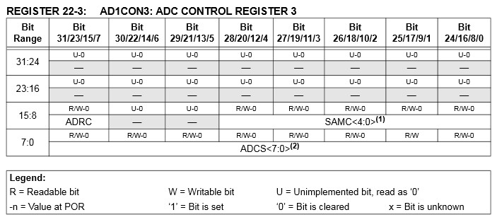

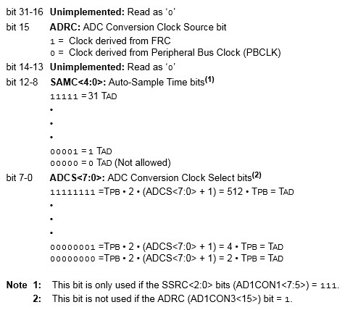

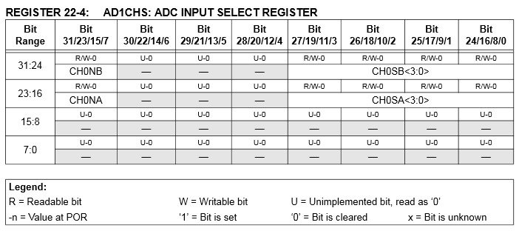

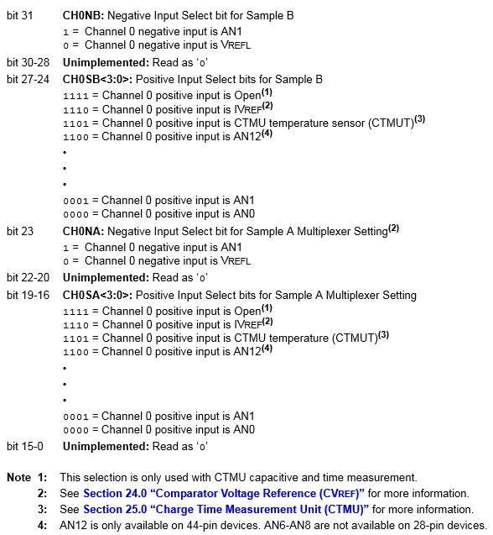

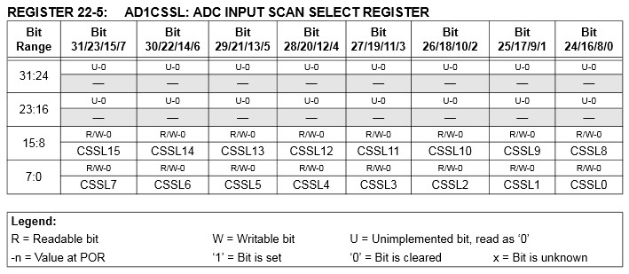

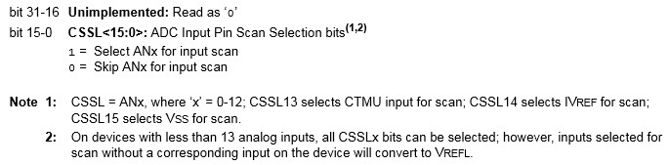

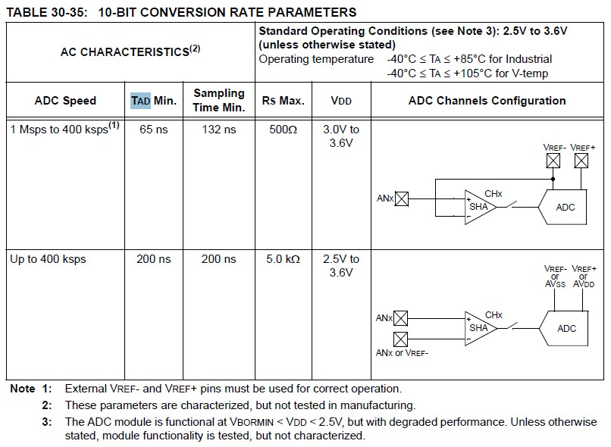

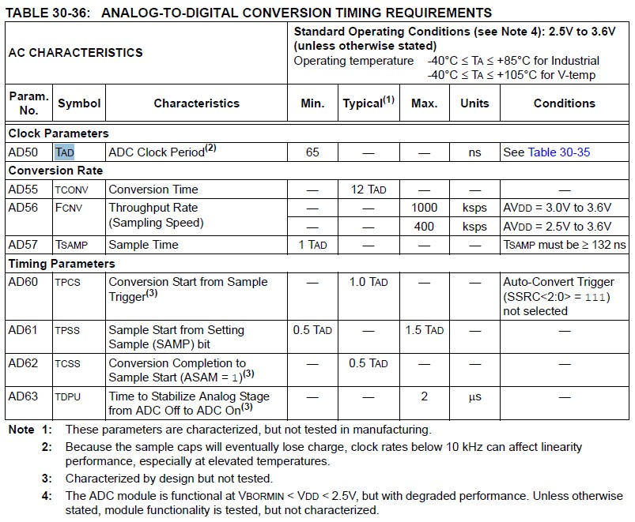

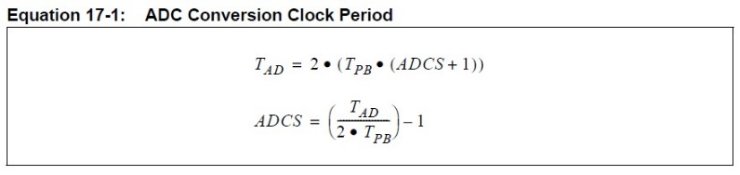

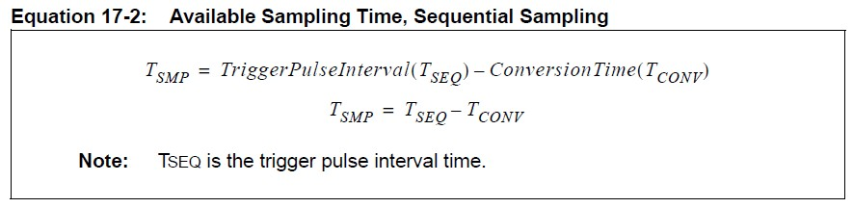

**UARTS:**

**Overrun Error –** A new character has arrived before previous character has been read.

**Underrun Condition –** The UART’s transmit buffer is empty while communication has been taking place.

**Framing Error –** Start and/or stop bits are in error. That is, the line is not low where a start bit should be, or it is not high where the stop bit(s) should be located.

**Parity Error –** The parity bit (if present) is not the value should be for the transmitted data bits.

**Break Condition –** A certain number of consecutive 0’s (generally more than a complete character) have been received. Can be sent intentionally to tell the receiver communication is finished.

**Baud Rate:** Symbols per second

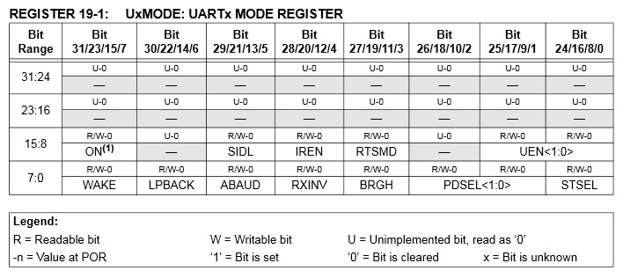

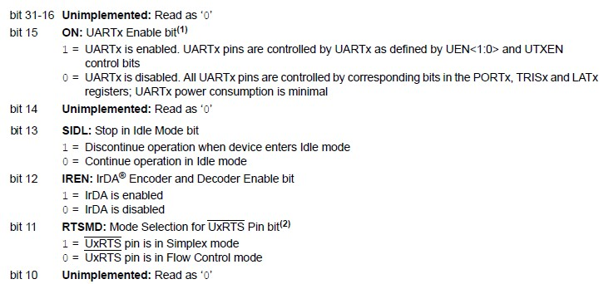

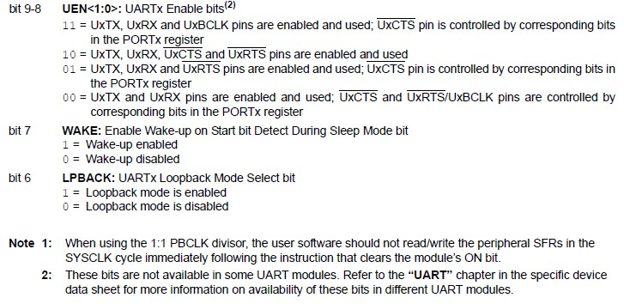

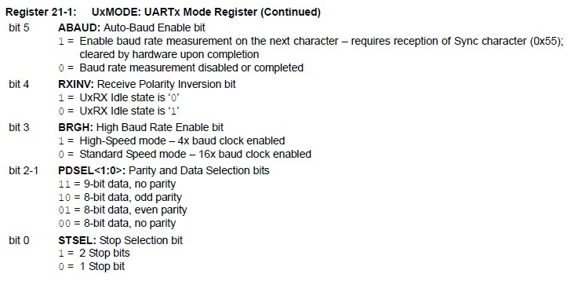

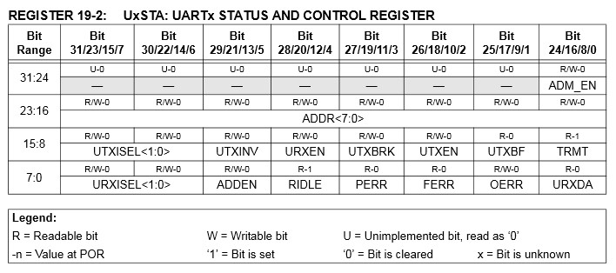

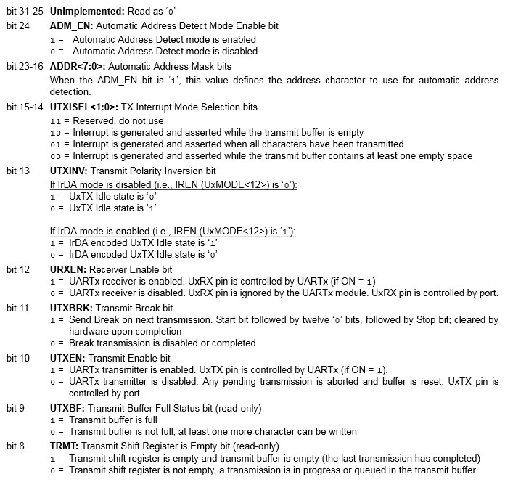

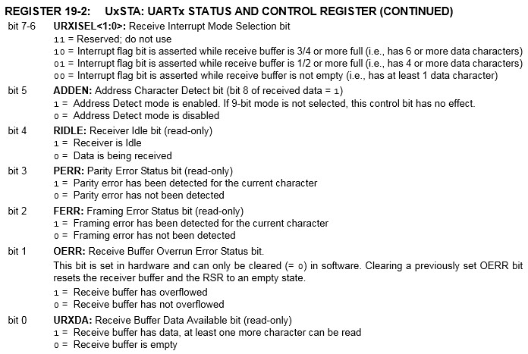

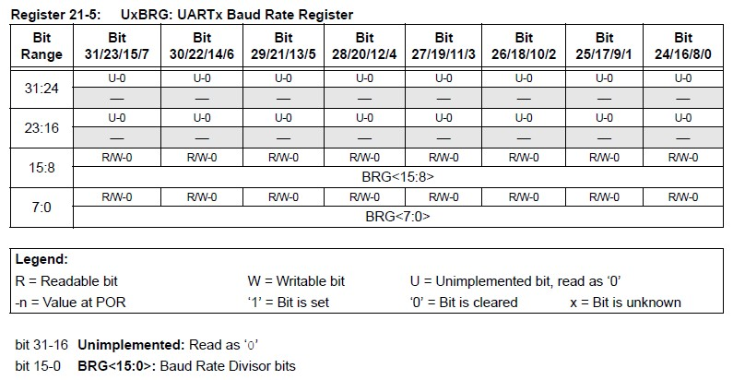

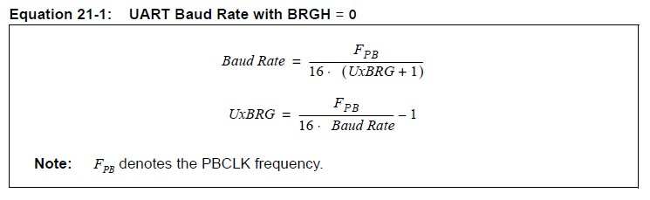

If BRGH = 1 then replace 16 with 4 ^.

**Stepper Motors:**

- Unlike many motors, they have full torque at stand-still and have excellent response to starting, stopping, and reversing.

- They don’t need brushes for commutation, so they have a longer motor life depending primarily on bearing and coil life.

- They can achieve very low speeds and only require open-loop control

- Furthermore, their speed is determined by the period of these pulses, not by their voltage.

- **Disadvantages:**Resonance can be a problem if not controlled.

Do not perform as well for high-speed applications.

**Stepping Modes:**

**Wave Drive Mode:** one by one A – B – A’ – B’

**Full Step Drive:** 2 at a time AB – BA’ – A’B’ – B’A

**Half Step Drive:** combo of above two AB-A-BA’-A’-A’B’-B’-B’A-A

**Micro Stepping:** smaller step sizes

**Stator** – Stationary (generally) part of the motor held in place by the outer casing of the motor.

**Rotor** – Inner part that rotates in response to changes in the activation pattern. It is supported at each end by bearings and includes a projecting shaft for the connection of the load.

**Stator Teeth** – Radial projections on the stator which provide a more precise path for the magnetic flux to flow between the stator and the rotor and produce the motor’s movement.

**Rotor Teeth** – Radial projections on the rotor which are also used to provide a path for the magnetic field that produces the motor’s movement.

**Multi-Stack Variable Reluctance:** rotor teeth lose to (not equal) stator is multiple of phases.



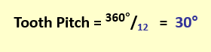12 = rotor teeth

**Hybrid:** Rotor teeth > Stator Teeth (still multiple of poles)

